**Installation:**

If using Google Colab use !pip install polymerization-planner, else use pip install polymerization-planner

For ATRP (Three optimizable reagents, metal, ligand, photocatalyst (PC)

**Example usages of** polymerization_planner **with ATRP.**

These equally can be applied to PET-RAFT (For reaction only requiring two additional optimizable components E.g., photocatalyst (PC) and chain-transfer agent (CTA).

Here we are making different reagent molar ratios,which might require need to reduce either metal, ligand, PC volumes in order to allocate space for a reagent needing a higher ratio.

**Input to the function is a path to a single excel workbook having 3 sheets.**

1. The first (Must be named: Sheet1)sheet defines the Reagent ratios for the Monomer, Initiator, Metal, Ligand and Photocatalyst [M] = Stock monomer concentration, The [I], [Metal],[L], [PC] are the stock concentrations of Initiator, Metal and Ligand respectively, an input is necessary but if the script determines using another concentration is more efficient to minimize reagent preparation this will be overwritten. Can always just put the highest concentration available. The columns must match the naming shown below

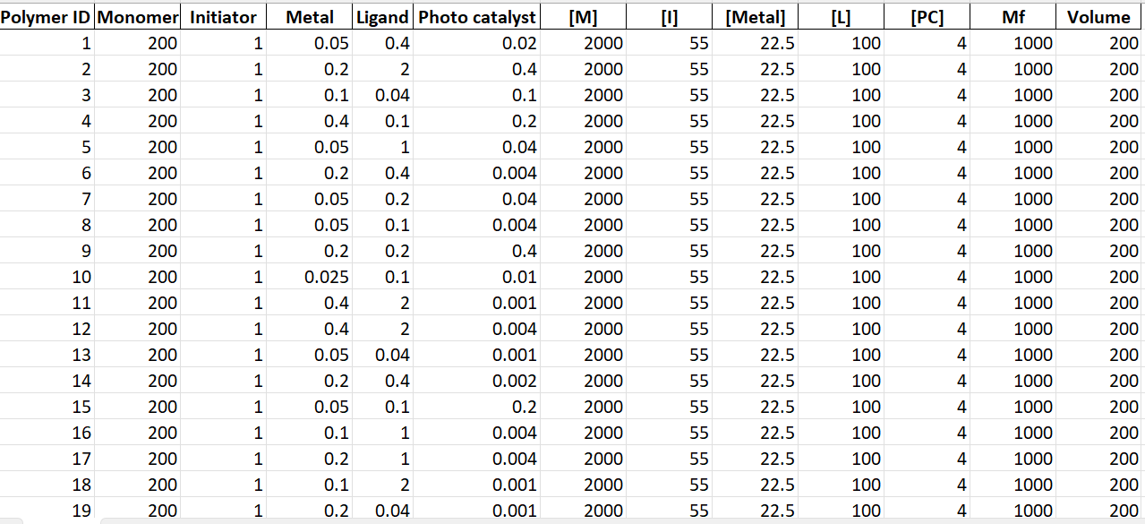

1. The next sheet has information on the monomer name. However if making copolymers these must all have the same concentration for example if making a 50% MA and 50% HEA both HEA and MA must have the same concentration as this will determine their volume based on percent. If making Homopolymers of different monomers at varying concentrations that is ok. However, if going to the same well / same polymer these must be equal stocks.

1. **A screenshot of a computer

   AI-generated content may be incorrect.The third sheet (Sheet3) has the possible reagent concentrations the script can consider when making ratios. The most straightforward approach is to just make a high concentration of each reagent, then pass dilutions that can be made by serial dilution to save time for the experimenter.**

**\*\*\*\* All sheet column names must match the examples shown and include all sheets, as a single file.**

**Now can import the module, by calling**

If using Google Colab use !pip install polymerization-planner, else use pip install polymerization-planner

Might need to restart session if in Colab if after installation you get a message saying the modules isn’t available, means need to “refresh” so the function can be used.

Once this is installed can now import the function

Can upload the excel sheet to the colab directory or to a folder in your drive, the script will save to the parent folder from where the file was read. Here I just uploaded to the colab notebook directory